Hiking in Greece
Hiking The Vikos Gorge
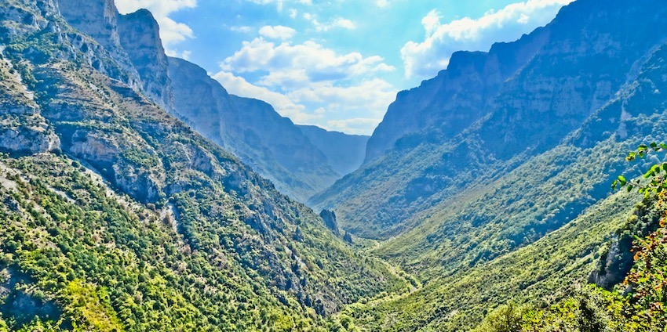

The Vikos Gorge lies in the North Pindus Mountains in the historic area of Epirus, 30 odd kilometers north of Ioannina and 24 miles from the Albanian border. The area, called the Zagori, has 44 villages called the Zagorohoria.
This article appears in Matt Barrett’s Greecetravel.com
by Janet McGiffin
Janet McGiffin is the author of the four-volume Empress Irini series about the 8th Century Byzantine Empress Irini who was one of two women to hold the throne in her own right. Janet can be reached through her website, Janetmcgiffin.com
"Upwards and Downwards, One and the Same"--Heraclitus
In the 6th century BC, the philosopher Heraclitus said, "A road is, upwards and downwards, one and the same." Those who have hiked the Vikos Gorge will say this description fits perfectly. Even with the varied terrain and vistas, anywhere one walks or points a camera is the same wild beauty, changing and not changing season after season.
Ask any Greek to name five beautiful gorges of Greece and the first response will be "The Vikos."* This quick name recognition may be because the bear and wild boar protected in the Vikos Aoos National Park wander out occasionally to feast on farm animals and get on the nightly TV News. The Vikos Gorge also borders popular Greek ski areas and area hotels are full during snow season.
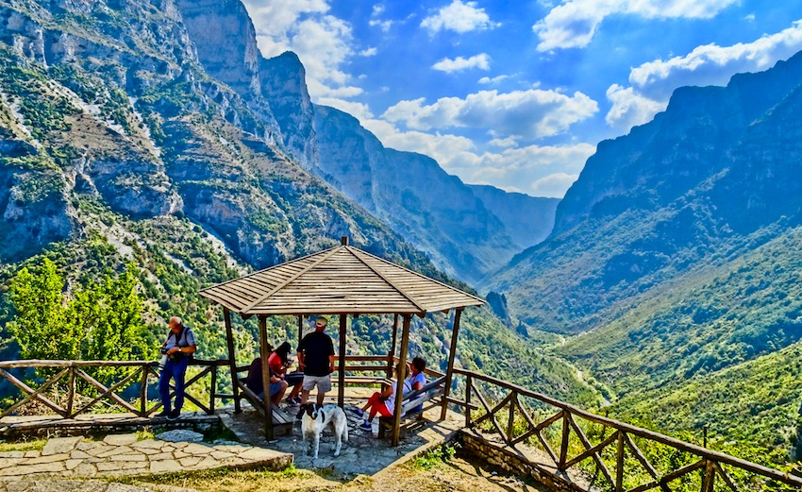
But for hikers, the Vikos Gorge comes first because of its beautiful interconnecting footpaths of many levels of expertise that link stone villages tucked into folds of mountains. And a cool breeze that drifts through the tree-shaded Vikos gorge makes it possible to hike all summer, even when the rest of Greece is baking under blazing August sun. By the end of August, the Vikos Gorge is already tasting the crisp nights of autumn and the maples, beech, fig, and oak trees along Greek National Trail #03 that follows the Vaidomatis River through the gorge are ablaze with color.
The Vikos Gorge lies in the North Pindus Mountains in the historic area of Epirus, 30 odd kilometers north of Ioannina and 24 miles from the Albanian border. The area, called the Zagori, has 44 villages called the Zagorohoria. The 12-kilometer gorge itself can be hiked in two or three parts: Monodendri north to Vikos; Vikos to Papingo, and Monodendri south to Kipi and its lovely arched stone bridges.
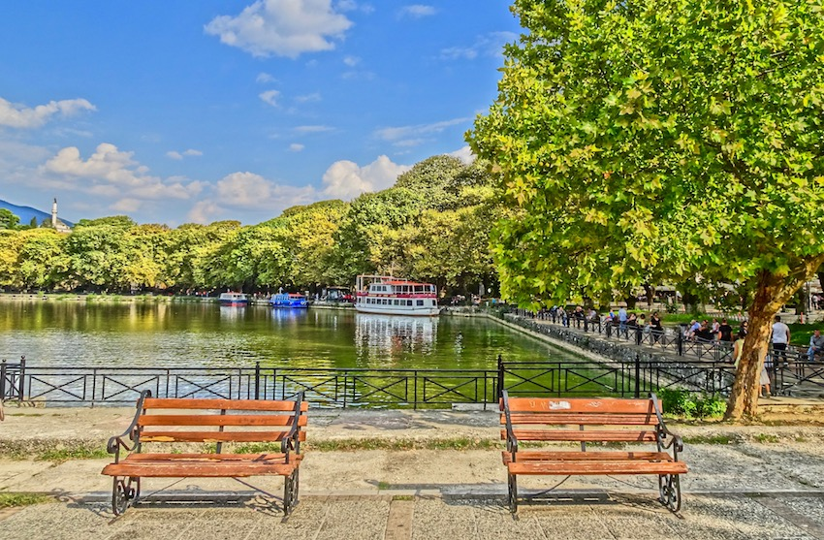
Part of the pleasure of hiking the gorge comes from the long journey to get there. A car trip from Athens to Ioannina takes seven hours with an advised overnight in Ioannina to enjoy this lakeside town with its Ottoman-flavored bazaar and inexpensive eateries rimming the lake. The Archeological Museum is not to be missed as the exquisite displays of ancient glass and bronze work provide a quick sense of this part of Greece, inhabited for six thousand years. During the Roman and Byzantine eras, the road to Rome from Constantinople, the "Egnatia," ran through Ioannina and today the new East-West highway, the Egnatia Odos, follows much the same route. See Matt's Ioannina Page.
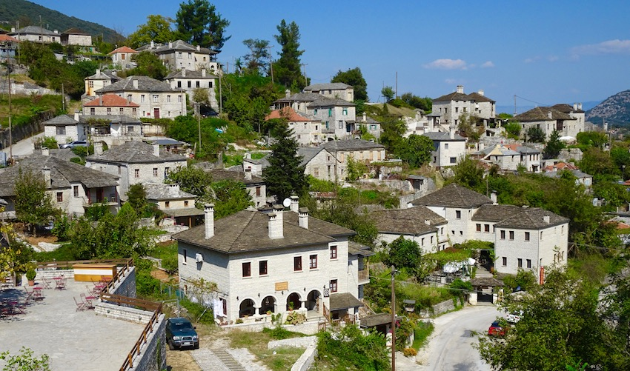
After Ioannina, it's only 16 kilometers to the first villages of the Zagori. The mountain road is steep, narrow, and winding. Local drivers tear around hairpin curves leaving little space for oncoming traffic. On one recent journey, a helicopter was picking a bicyclist out of a canyon-a miscalculation of brakes and curve.
By bus from Athens, the journey requires calculation to connect with the smaller buses to the Zagori. Long-distance (KTEL) buses leave Athens Bus Terminal A (Kifissou Street) nearly every hour starting at 6 am. The trip is approximately seven hours with a spectacular crossing of the new bridge at Rio. Buses can be packed with Albanians making bus connections in Ioannina for the Albanian border so arrive at the station early if you need to make a connecting bus to the Zagori.
Two bus services leave Ioannina for the Zagori. One goes to Monodendri and villages near the south end of the gorge, leaving Ioannina at 6:15 and 4:15 pm. The second goes to Mikro Papingo and Megalo Papingo and the villages near the north end of the gorge, Monday, Wednesday and Friday at 5:15 am and 2:30 pm.
The village of Monodendri, on the rim of the gorge near the south end, is a good spot for those who want to hike the entire gorge as well as view the famous stone arched bridges over the river below the gorge. It's a restored stone village of walled stone courtyards with fortress-like gates. New construction matches the old architecture. Other short hikes out of Monodendri are suitable for hikers not eager to handle the vigorous gorge hike. Nearby Vitsa is also good for hiking the gorge, although it's a distance to reach the entrance to the gorge.
The villages of Mikro Papingo and Megalo Papingo, at the north end of the gorge, are better suited for hikers who want to hike the gorge as well as east into the Gamilla range.
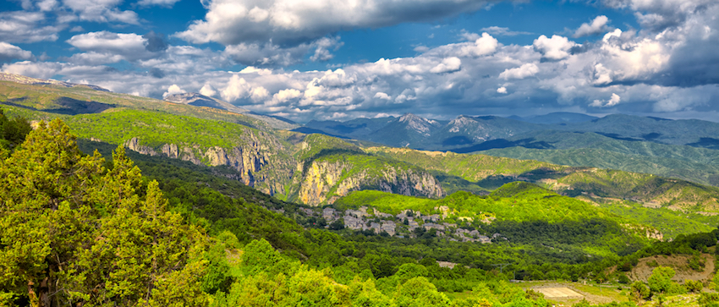

Hikes around Monodendri besides the gorge
The abandoned Monastery of Agia Paraskevi is nearly a kilometer down the new kalderimi from the lower platia in Monodendri and makes a nice limber-up after a long bus or car journey. The view up and down the gorge are the perfect introduction to the hike ahead. Continuing around the corner of the cliff is the "Megali Spilia", a cave reached by a narrow path with a scary drop-off for those who enjoy heights. For an even better view of the gorge, follow a signposted path near the open-air theatre at the top of the gorge trail, where traveling troupes put on performances in August at the expense of the Greek Ministry of Culture. There is a pleasant stroll along the rim to a small church and long views across the Pindus mountains.
A longer day walk is to follow the road up from Monodendri to the abandoned Monastery of Profitis Ilias. A sign to the Monastery. The view of Monodendri is charming, as is the downward path through the forest to Vitsa where several establishments serve lunch under a broad plane tree overlooking a ravine leading into the gorge.
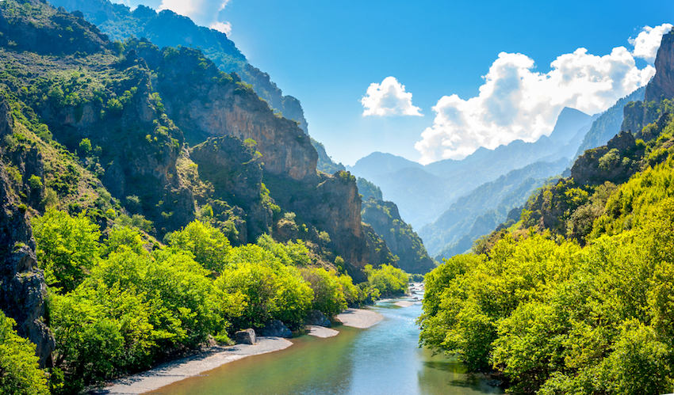

Monodendri to Vikos or Papingo: Hiking the Gorge
From Monodendri, the trail into the gorge drops steeply to the Voidomatis River. The trail turns left while still in the trees and continues through the woods in a charming, lovely, and pleasantly graded footpath that parallels the river. Said to be the deepest gorge for its height, the Vikos Gorge measures 2950 feet (900 meters) deep and 3600 feet (1100 meters) from rim to rim. At another spot, the depth measurements are 5,927 feet (1,780 meters) deep, from
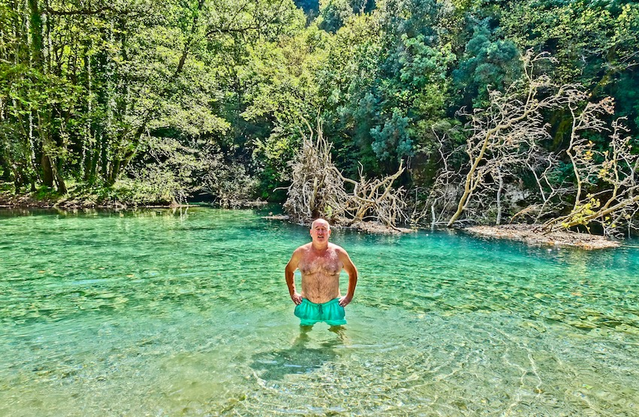

Papingo to the Panagia shrine at the springs.
With leisurely stops for photos and snacks, the hike from Monodendri to Vikos takes something over five hours. The ascent at Vikos is steep and in full sun and it's a relief to reach the vine-shaded tavernas of Vikos at the head of the footpath. Excellent wild boar stew is sometimes on the menu. Followed by thick slabs of watermelon for dessert, it's perfect for getting hikers back on their feet for the next part of the gorge-Vikos to Papingo.
After re-descending into the gorge, it's a pleasant stop at the frigid headwaters of the Voidomatis River, just right for dabbling hot feet. A short distance back toward Monodendri is the turnoff to Papingo. Late afternoon is excellent for ascending the steep treeless switchbacks of the first part of the footpath as it sits in the mountain shadows formed by the setting sun. The trail is varied-breath-holding traverses of steep open hillside, narrow bits edging around cliff-hanging boulders, and long flowing passages through dense forest. (Yes that it Matt in the photo about 1 minute before his first heart attack)
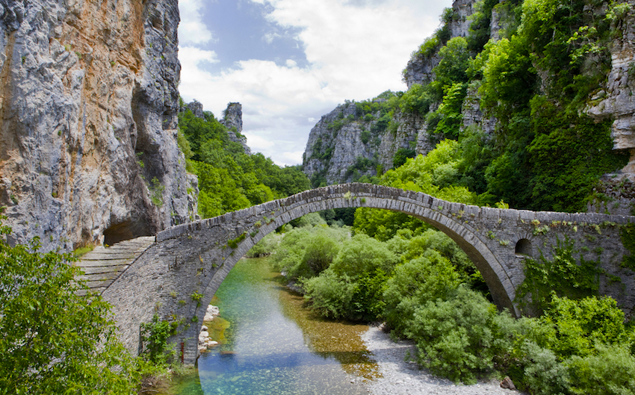

Monodendri to Kipi: the 18th Century Stone Bridges
Monodendri or Vitsa are excellent places to set off for along the dry river bed to Kipi and view the graceful arched stone bridges along the way. Sometimes referred to as "packhorse" bridges, these one-, two-,or three-arched bridges were parts of cobblestone roads that linked these remote villages until roads were opened in the 1950s. Erected in the 18th and 19th century by itinerant builders who built over 500 bridges in Greece and the Balkans, the Kipi bridges were financed by local families and generally named after them.
Armed with a map and a guidebook, one can easily spot the arching bridges and the stone "kalderimi" paths that lead upward to the various villages. The Misiou Bridge lies below Vitsa; the Kokoros is beside the main valley road; the Knododimou is between Kipi and Koukouli, and the rest are either side of Kipi. A triple span, the Plakida, is downstream and three more are upstream from the village.
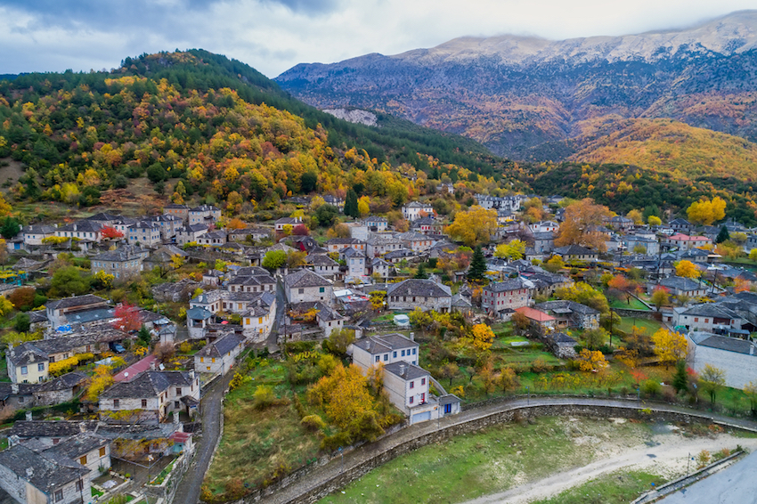

Papingo to points East
For the serious hiker, Papingo is a jumping-off point for days of enjoyment pushing east into the Gamilla range. There is a pleasant ascent to the refuge on Astraka col and from there, one can choose from routes that circle back or continue onward. There are restaurants and hotels in Papingo as well as a white water rafting company and other eco-touristic ventures and it is a short walk to the Papingo Rock Pools. There are two villages actually, Micro and Megalo (small and large). See Zagoria Hotels
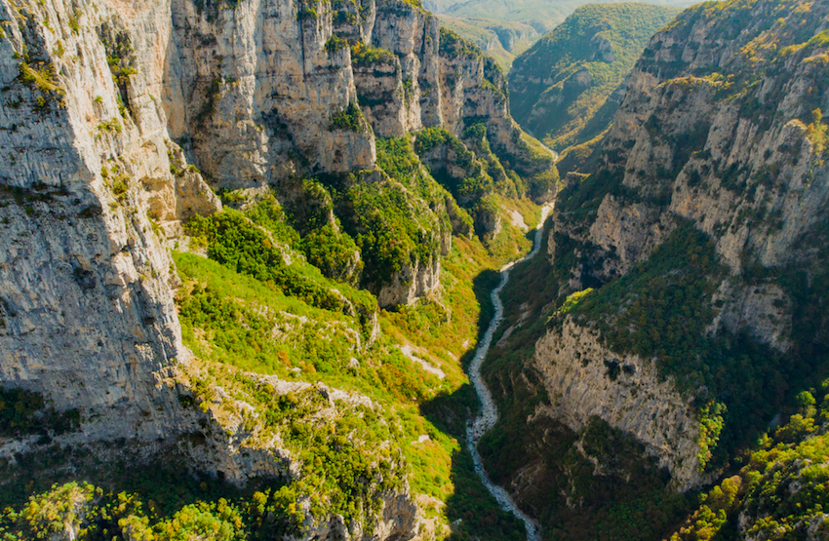

Logistics: Getting from here to there
The challenge of hiking the Vikos Gorge is how to return to your point of origin. The long, winding gorge and its deep side ravines separate villages from each other. It can take hours to drive to a village that is visible across the gorge. Local buses make twice a day flying stops in the village squares with one service connecting the villages near Papingo and the other connecting the villages near Monodendri. On our hike from Monodendri to Kipi, we got lucky. A bored TV crew interviewing locals regarding a mule-eating bear spotted us climbing out of bear-infested territory and happily turned their cameras on us. Following a nice lunch, they drove us back to Monodendri.
For our hike to Papingo, however, we arranged with a local Monodendri resident to pick us up, a service he provides. The price was steep, but worth it considering the nippy air after sunset that made the warm truck very inviting. The drive back took nearly an hour.
One can hike a round trip, of course. Heraclitus says the road is the same, up or down, but trails can look vastly different when traveling the opposite direction. Or one can back-pack from one village to the next, although passages are steep and there are long upgrades. One could even pay to have one's luggage sent ahead.
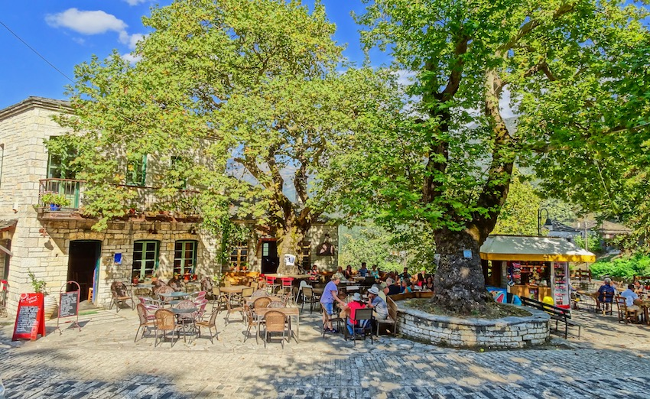

Your Dining Pleasure
Epirus fare is different from the rest of Greece, and meat-eaters can sample goat soup (soupa katsikiou) or wild boar (agrio gourounou), along with the usual veal or chicken. Horopita is a satisfying full meal of thick pita covered with sliced garden vegetables and trahanas. Trahanas, a staple of the Byzantines, is emmer mixed with milk or yogurt of goat or sheep and dried. Later it is reconstituted as a sour gruel and used in horopita to thicken the vegetable sauce. Also you will find restaurants serving fresh trout and many of the same dishes you are accustomed to if you have traveled in other parts of Greece.
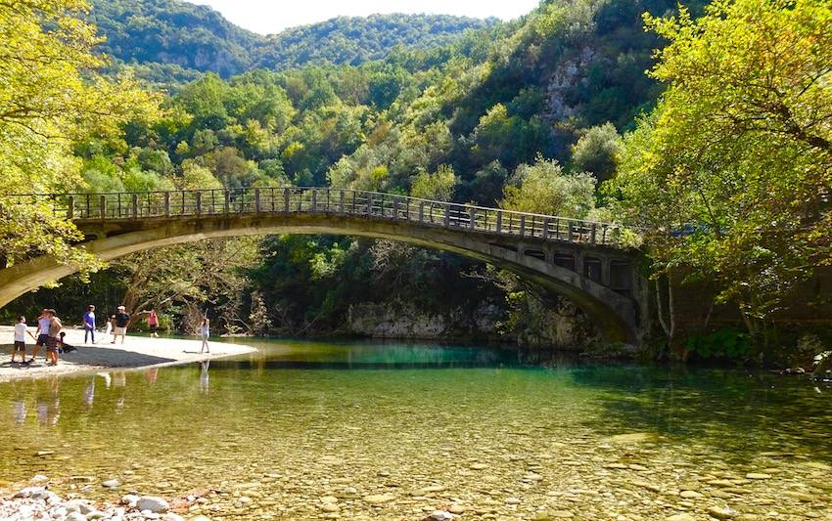

Foreign hikers predominate
Greeks may have excellent name recognition of the Vikos Gorge, but most summer tourists speak every language but Greek, though this has begun to change as a new generation of young people have taken to the hills with off-road vehicles, rafts, kayaks and hiking boots. Booking ahead is a good idea though in the off season you should be able to find something. For Hotels and guesthouses see Booking.com's Zagohoria Pages and Matt's Hotels of Greece Ipiros Page
*The other well-known gorges of Greece are the Vinianis, Samarias, Vouraikou, Vothona

